Sharon is an ST1 trainee.
She initially started off as a registrar in Anaesthetics. But she developed depression and had to be off work. After 2 years, things got better and she decided to apply for General Practice and was successful in the recruitment process.

The trainer’s main difficulty is trying to get her to put things in her ePortfolio.

Trainer says:
- I really like her
- However, she can be very tearful when I do CBDs (and sometimes COTs) with her. Sometimes I feel I have to tread very carefully or on rice paper.
- But she is clearly keen to learn.
- At first she had lots of confidence issues – but now she is getting better and preparing and showing her videos.
MSF:
- She’s a lovely girl, patients love her
- Adorable.
- Very helpful when approached.
- Runs terribly late.
- Lateness – patients have walked out. Sometimes running 1 hour behind.
- District Nursing team love her – says she interacts with them lots

Clinically
- Asks me weird clinical questions sometimes – sometimes questions I feel she should know the answer to.
- Thorough documentation.
- Has loads of Systm1 tasks outstanding. Some of these are urgent’ish.
- Not very good at dealing with her results in a timely way.

CSR
Very person-centred in consultations. Seems to have adopted this intuitively.

RDM-p category | The Evidence | Our reasoning/things we want to explore
R+p+ | I really like her
RD | Tearful. I have to tread carefully | ?Low self-esteem, lack of confidence
p+ | Keen to learn
RD | Confidence issues | ?Low self-esteem, lack of confidence
R+p+ | Lovely girl, patients love her
R+p+ | Adorable
R+p+ | Helpful, approachable
Mp | Runs late
Mp | Runs v late, patients have walked out
R+p+ | DNs love her
DM | Asks weird questions
M+D-D+p+ | Thorough documentation
DMp | System1 tasks outstanding
DMp | Not dealing with lab results
R+p+ | Person centred

Step 3 – create an Edwards’ diagnostic map (to capture and classify potential issues related to knowledge, skills and attitudes).
RELATIONSHIP
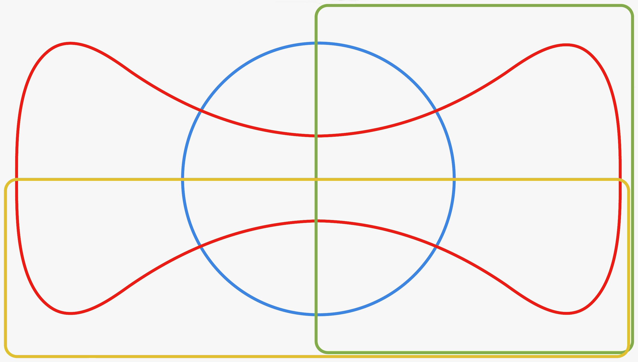
DIAGNOSTICS
MANAGEMENT
PROFESSIONALISM
X
✓
X
X
X
X
X
X
✓
✓
✓
✓
✓
✓
✓

I WONDER IF SHE HAS PROBLEMS IN DIAGNOSTICS AND MANAGEMENT
DISCUSSION
Relationship – Sharon has a poor relationship with the e-portfolio. Who will see it. Not comfortable revealing her thoughts and inner feelings | SKIPE  - Knowledge – who will see it  - Internal factors – revealing her thoughts and inner feelings (anxiety)  - Past factors – previous bad experiences with consultants (sign of weakness)
Diagnostic – Sharon is not sure what to include and what not to include. | SKIPE  - Knowledge – does not know what a good entry even looks like.  - Knowledge - Also does not know what sorts of things to include.  - Internal/Past factors – anxious about showing herself up/weaknesses. Wants to write perfect entries which then gets put of.
Management – finding it difficult to keep on top of things. Hence little time for eP. | SKIPE  - Skills – management and organisation  - Knowledge – management and organisation  - External factors – has 2 children to look after
Professionalism - | SKIPE  - Understands importance of the eP

OUTCOMES/NEXT ACTION
- Relationship – reassured who will look at them and how sympathetic they are. Reassured writing about emotions is not a weakness but mature. Illustrated with an example.
- Diagnostics – reassured, entries do not need to be perfect. Went through ISCEE model of reflection. Skills – helped tweak some of her entries to make them better. Discussed what a sorts of entries make good entries.
- Management – was not delegating tasks (e.g dictating referrals, using admin effectively), hence no time during surgery hours for looking at eP. Also, husband to look after kids one evening per week.

